CCSI 3161 Assignment #2 – Marking Sheet

Student Name | Riley Devitt

Part | Breakdown | Comments | Max. | Mark
(i) | - 6 or more planets around sun (4)  - various colors (0.5)  - various sizes (0.5)  - various speeds of rotation (0.5)  - 4 moons (1.5)  - path rings (1.5)  - Elliptical orbit (1.5) | Well done | 10 | 10
(ii) | - random points in 3D outside solar system (1)  - twinkling colors (1) |  | 2 | 2
(iii) | - enterprise read in from file (3)  - enterprise drawn correctly (5)  - enterprise is constantly below and in front of camera (2) | （3） -2 enterprise is above now:  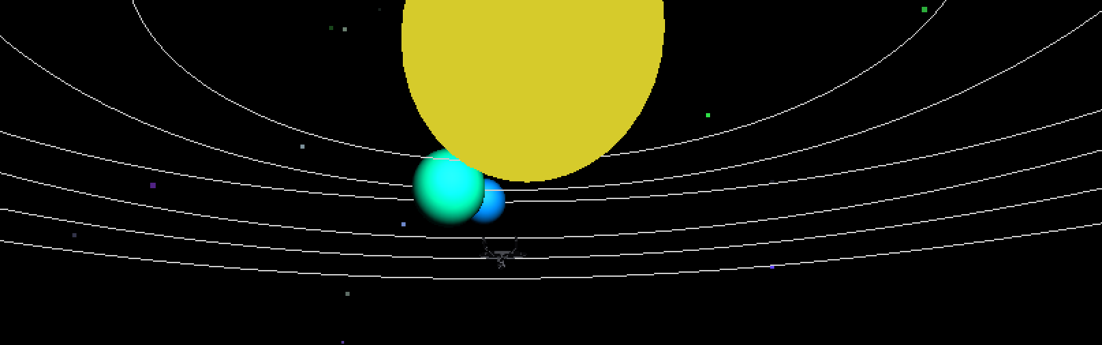  （2）-1 enterprise is too far away | 8 | 5
(iv) | - up/down, left/right, forward/back movement (1)  - can continuously move in each direction (1) |  | 2 | 2
Total |  |  | 22 | 19

# of Days Late | Late Cost

Grand Total | 22 | 19

